Cheshire East Borough Council
ELECTION OF PARISH COUNCILLOR

Thursday 6 May 2021
The following is a statement as to the persons nominated for election as Councillor for the

Pickmere Parish Council

STATEMENT AS TO PERSONS NOMINATED

The following persons have been nominated:

Candidate's Names (Surname First) | Home Address | Description (if any) | Name of Proposer (Surname First) | Decision of Returning Officer that Nomination Paper is invalid or other reason why a person nominated no longer stands nominated*
CARSON Sarah Elizabeth | (address in Cheshire East) | Independent | Wilkinson Stephen

The persons above against whose name no entry is made in the last column have been and stand validly nominated.

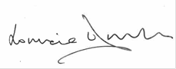

RETURNING OFFICER

