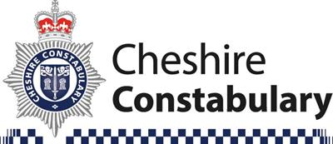

PC John Milman will be
holding a Police surgery at:
PICKMERE VILLAGE HALL
FRIDAY 17 FEBRUARY 2023
10.00 a.m. to 11.00 a.m.

Any questions or concerns?
Any local issues?
Please drop in and have your say!

